Tutorial 5

Original architecture
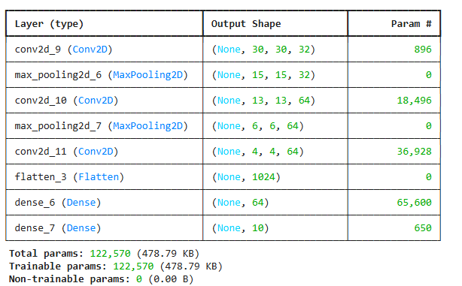
Training Curves:
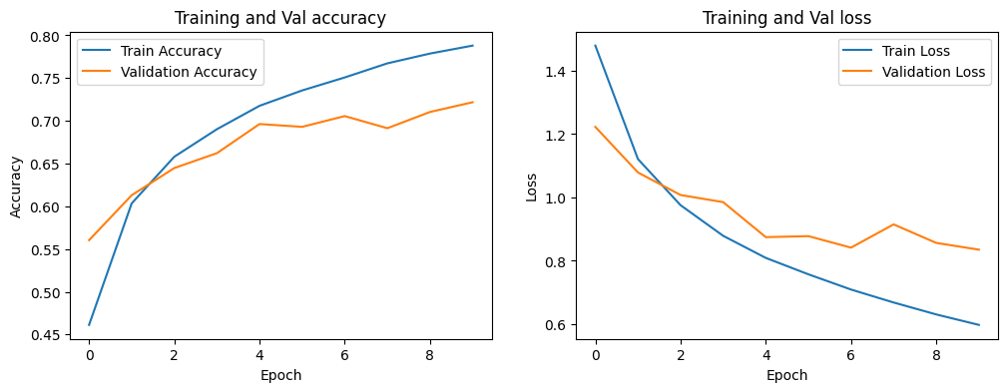
Performance:
Training accuracy: 0.7923 –
Training loss: 0.5842
Val_accuracy: 0.7218
Val_loss: 0.8352
Test accuracy: 0.72180

Increasing the filter size
The filter size was increased from 3x3 to 5x5. Here are the changes in the performance of the model and the training curves. One can notice that both training and test accuracy decreased by increasing filter size.
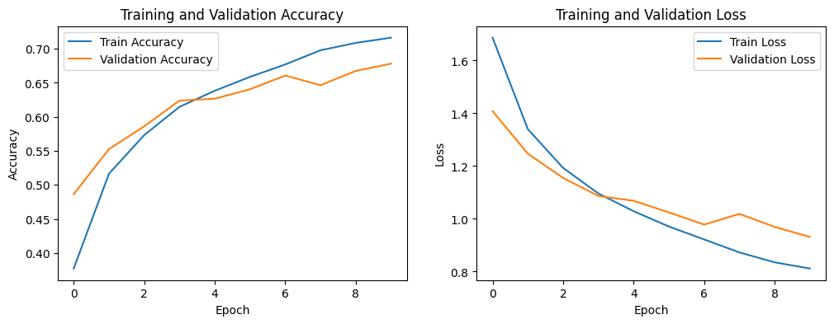
Train Acc: 0.7163 | Val Acc: 0.6782 |Train loss: 0.8117 | Val loss: 0.9313
Test Acc: 0.678

Optimized Model for CNN
Here is the optimized model that was created. The third convolution layer’s neurons were increased from 64 to 128. The number of fully connected layers were also increased, as well as the number of neurons.
----------------------------------------------------------------
Layer (type) Output Shape Param #
================================================================
Conv2d-1 [-1, 32, 32, 32] 896
MaxPool2d-2 [-1, 32, 16, 16] 0
Conv2d-3 [-1, 64, 16, 16] 18,496
MaxPool2d-4 [-1, 64, 8, 8] 0
Conv2d-5 [-1, 128, 6, 6] 204,928
MaxPool2d-6 [-1, 128, 3, 3] 0
Linear-7 [-1, 256] 295,168
Linear-8 [-1, 64] 16,448
Linear-9 [-1, 32] 2,080
Linear-10 [-1, 10] 330
================================================================
Total params: 538,346
Trainable params: 538,346
Non-trainable params: 0

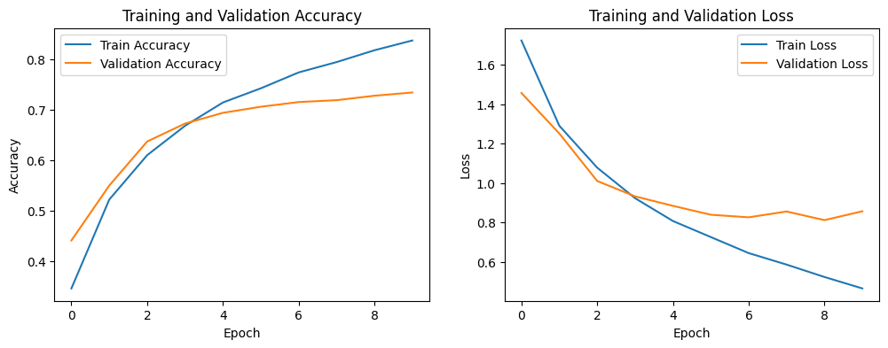
Performance
Train Acc: 0.8366 | Val Acc: 0.7338 |Train loss: 0.4662 | Val loss: 0.8572
Test Acc: 0.734

Both the test and training accuracies were larger than the ones in the original model. However, it is likely that overfitting may be happening because the difference between the training and validation accuracy is around 10% whereas in the original model it was around 7%.

